Name : Pranali Sonawane
Subject : CCNA
Lab Practical 1 – DHCP Configuration:
First, we took one router, one switch, and ten PCs. The PCs were connected using copper straight-through cables, and the router was also connected to the switch using a copper straight-through cable.

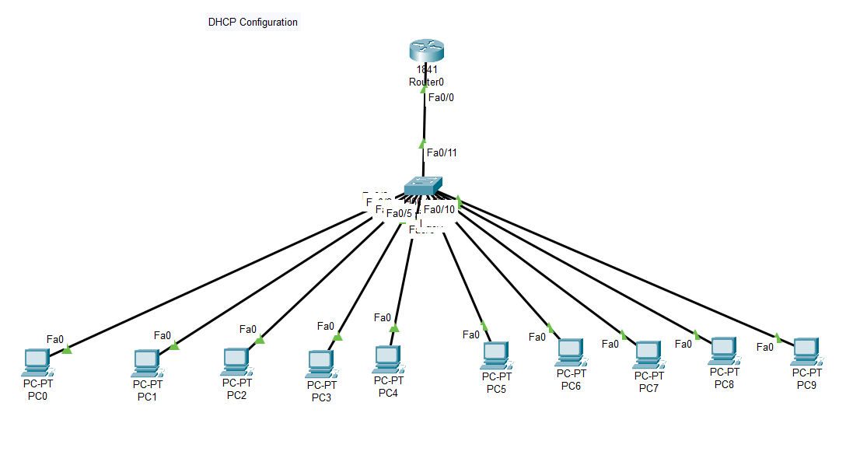

Open Router 0 – CLI prompt then type following commands
Router>enable
Router#configure terminal
Router(config)# hostname R1
R1(config)# interface fastEthernet 0/0
R1(config-if)# ip address 10.0.0.1 255.0.0.0
R1(config-if)#no shutdown
R1(config-if)#ip dhcp pool DHCP
R1(dhcp-config)# network 10.0.0.0 255.0.0.0
R1(dhcp-config)#default-router 10.0.0.1
R1(dhcp-config)#exit
R1(config)#end
R1# show ip dhcp binding
Open pc 0 – desktop—ip configuration – Click on DHCP(DHCP request Successful)

Open pc 1 – desktop—ip configuration – Click on DHCP(DHCP request Successful)

So on upto the pc 9.

Again go to the Router 0 :

R1# show ip dhcp binding

